**Embedded Integration (OLED + AWS IoT + ADXL357)**

In order to have the application integrated, a second I2C bus was exclusive dedicated to the accelerometer, this was necessary as OLED display frequency diverges of ADXL357.

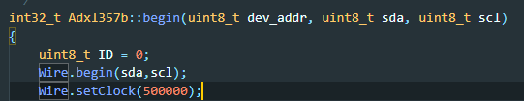

Figure - ADXL357 Frequency work

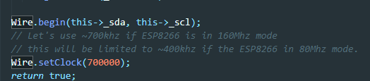

Figure - OLED Frequency work

Modifications:

* Define a macro to avoid I2C class overriding.



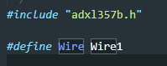

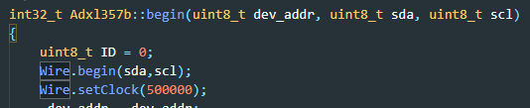

* Pass SDA, SCL pins as a parameter to Adxl357b.begin method removing the hard code fix explained in log 10.

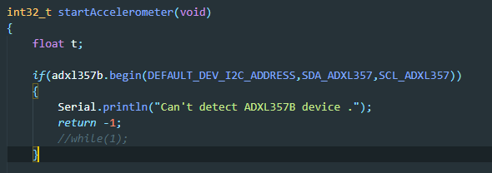

**Results**

